Speakers
Lin Guijun, Vice President of University of International Business and Economics (UIBE)
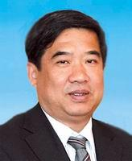
Lin Guijun is a doctor in Economics, a professor，an advisor for doctors, “ Model Worker of Beijing” and a distinguished professor recognized by the State Council. Mr. Lin is currently the assistant director of the Academic Degree Committee of UIBE, the assistant director of the Academic Committee, a member of the Applicable Learning Appraisal Group of the of State Council, a committee member of the Economics Steering Committee of the Ministry of Education (the convener of the Department of International Economy and Trade), a committee member of the Social and Scientific Committee of the Ministry of Education, the vice-chairman of China’s International Commerce School and the vice-chairman of the Beijing Economics League. Since 1995, Mr. Lin has served as associate dean of School of International Trade and Economics of UIBE and vice president of UIBE, etc.
Mr. Lin has acted as a visiting scholar to many overseas institutions for lectures, seminars and academic research projects, including the Department of Economics of the University of Manchester, the Chinese University of Hong Kong, the Bocconi University of Italy, the Abu Academi University and Turku School of Economics and Business of Finland, the Department of Economics of Columbia University, IMF, to name a few. Lin teaches a variety of courses such as China’s Foreign Trade Policy, International Monetary Theory, Welfare Economics, and An Advanced course on Microeconomics and Macroeconomics. Moreover, he has conducted a series of research projects mainly in international trade, policies on foreign currency and welfare economics. He is one of the pioneering scholars in both home and abroad to apply quantitative analysis into the research of China’s foreign trade policy. In recent years, he has published many papers on advanced economics in both domestic and international periodicals, such as Review of International Economics, China’s Economic Review, World Economy, Economics of Finance and Trade, Financial Research, etc. Domestically, he has published a book named the Research on RMB Exchange Rate.

Sun Zhenyu, Chairman of China Society for World Trade Organization Studies (CWTO), Ministry of Commerce of the People’s Republic of China (MOFCOM)
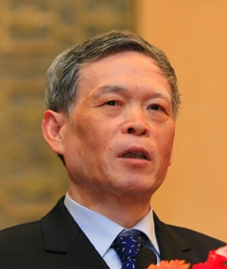
Sun Zhenyu graduated from Beijing Foreign Languages Institute in July 1069.From 1073, he served successively as staff member, Deputy Director and Director in the Third Department for Regional Affairs of the Ministry of Foreign Trade, Vice President of China National Cereals, Oil and Foodstuff Import and Export Corporation (COFCO), Deputy Director General and Director General of Department of American and Oceanic Affairs of the Ministry of Foreign Trade and Economic Co-operation (MOFTEC), and Vice Minister of MOFTEC. From 2002 to 2010, he served as the Ambassador and Permanent Representative of China to the WTO.

Wang Yanguo, Vice President and Secretary General, CICCPS
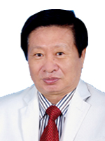
Mr. Wang now serves as Vice President, Secretary General and President of the Presidium to China International Chamber of Commerce for the Private Sector. Before, he served as Party Secretary, Vice President, Secretary General and President of the Presidium to the China Mining Association, President of mining industry branch of China Council for the Promotion of International Trade (CCPIT) and China Chamber of International Commerce (CCOIC). He has rich experience on grass-roots work, national ministries and national business associations’ work.

Walter Fust, Chairman of the Board of Globethics.net
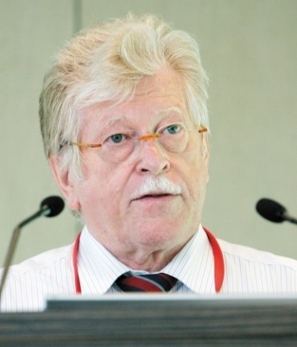
Walter Fust studied public administration and international relations at the University of St. Gallen (lic.rer.publ.) from 1970 to 1974. From 1974, he served consecutively in Bern, Geneva, at the Swiss embassies in Baghdad and Tokyo and then was assigned to the Government’s Integration Office (EFTA/EU). From 1985 to 1993, he served consecutively as personal assistant of Federal Councillor Dr Kurt Furgler, Minister of Public Economy, President of the Swiss Confederation, Managing Director of the Swiss Trade Promotion Office (OSEC) in Zürich and Lausanne, Secretary General of the Ministry of Interior and Ambassador and Director General of the Swiss Agency for Development and Cooperation (SDC).

Walter Fust was honored as Friendship Ambassador by China among his many honours and Awards by many countries. After his retirement from government service, he acted on the Global Humanitarian Forum in Geneva part time and on the board of different organizations and foundations, like the Chairman of the Board of Globethics.net, Geneva; Global Crop Diversity Trust, Bonn; the member of UN-Expert Committee on Public Administration (CEPA) and ITU/UNESCO Broadband Commission for Digital Development; the member of board of CATIE, Costa Rica, and so on.

Diana Madunic, Swedish CSR Ambassador
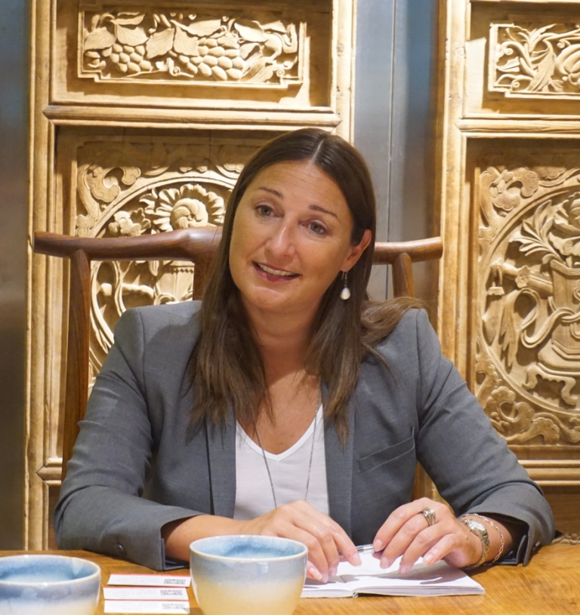
Ms Diana Madunic was appointed CSR Ambassador by the Swedish Government in April this year. The position is located at the Department for International Trade Policy at the Ministry for Foreign Affairs. Before starting her role as CSR Ambassador she worked in the European Correspondent Department of the MFA. She has previously worked with EU- and Foreign Affairs in the Prime Minister’s Office, at the Permanent Representation of Sweden to the EU, and in the Ministers Office of the MFA. Ms Diana Madunic has also worked at the Swedish Institute for International Affairs, and as an observer at the OSCE-mission to Skopje.

Hu Wei, Vice President, Zhenfa New Energy Company
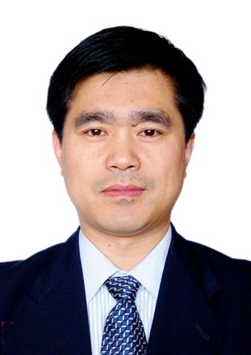
Mr. Hu is currently Vice President of ZhenFa New Energy Group.

Mr. Hu got his bachelor degree in the Electrical Engineering Department of Hunan University in 1984, and he gained his master degree in Hydraulic Machinery Department of China Agriculture University. Mr. Hu has attended Training Course on Irrigation technology and Extension hold by Israel CINADOC, Manufacturing Management at Warwick University, Coventry U.K, and Training on Renewable Energy Technology and Application in Demark by DANIDA since 1997.

Mr. Hu was engineer, senior engineer and lecturer at Chinese Agricultural Mechanization Sciences (CAAMS) until 2005. Then he has served as Deputy Director of Renewable Energy & Environment Institute of CAAMS, Program Manager of Program Management Office ( PMO) of Chinese- Danish Wind Energy Development Program ( WED), and Chief strategist of Sinovel Wind Group Co,.Ltd.

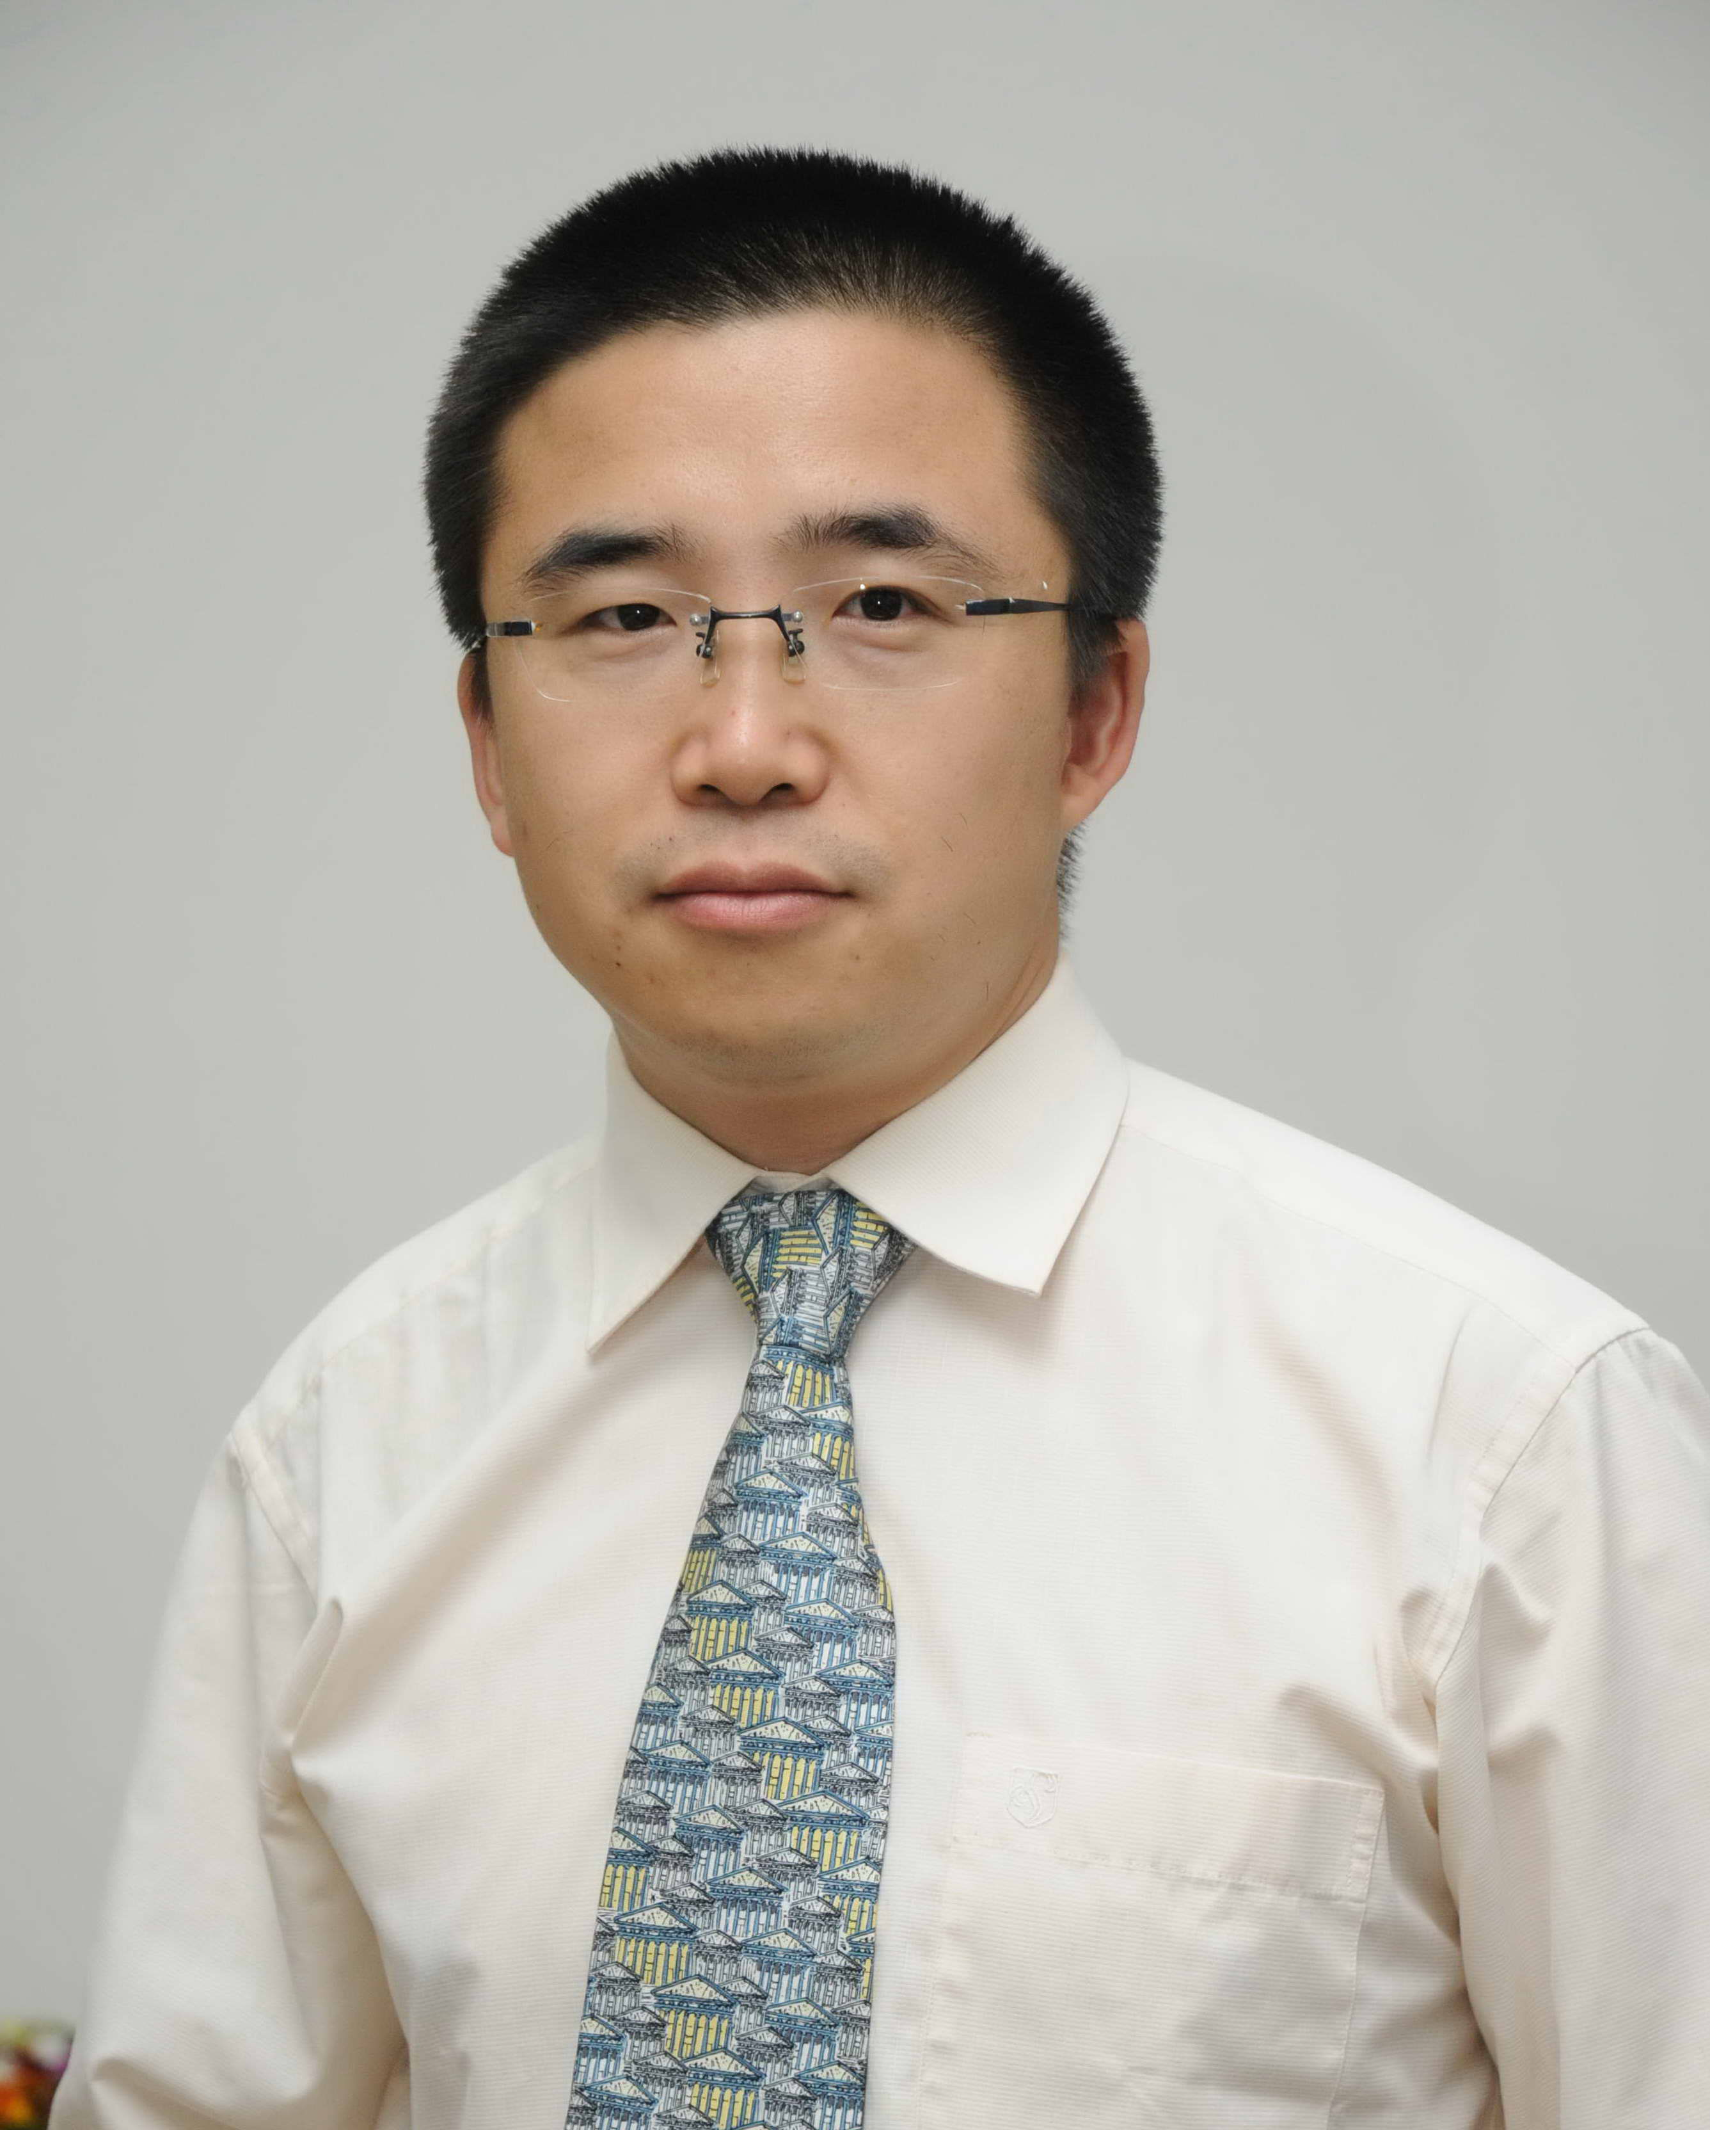
Liang Xiaohui, Deputy Chief Economist, China National Textile Information Centre
Dr. Liang is the Deputy Chief Economist, China National Textile Information Centre; Chief Researcher, Office for Social Responsibility, China National Textile and Apparel Council; Adjunct Professor, Peking University Law School

Mr. Liang used to be the program coordinator of the Human Rights Master Program at Peking University, China’s first professional human rights education project. In 2005, Mr. Liang joined the Office for Social Responsibility of China National Textile and Apparel Council as Chief Researcher, in charge of the development and promotion of CSC9000T, China’s first voluntary CSR initiative and social responsibility management system. Since 2008, Mr. Liang has been the lead expert in the development of other Chinese industry-specific CSR initiatives by business associations in China, and he has also involved in the development of several international CSR instrument initiated by international organizations including the UN and the OECD. Since 2006, Mr. Liang has taught the course “Business and Human Rights” at Peking University Law School and he is the first Chinese scholar teaching this course in China. Mr. Liang is now also a member of the Labour and Human Rights Working Group of the United Nations Global Compact, as well as a council member of World Economic Forum’s Global Agenda Council.

Bian Yongmin, Director, International Law Department, Law School, UIBE
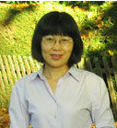
Dr. Bian has been working in Law School, UIBE since 1994, and now she is a professor and doctoral supervisor, as well as the Director of International Law Department, Law School, UIBE. Dr. Bian is also a researcher of Center for International Sustainable Development Law, Canada. Her main research fields are International law, Environmental Law, World Trade Organization Law, among which she has published many papers and articles.
Dr. Bian earned her bachelor degree on International Economic Law and master degree on International Law from China University of Political Science and Law, PhD from UIBE in 2002. From August, 2007 to January, 2008, she was a Visiting Fellow of the Lauterpacht Research Centre for International Law, University of Cambridge.

Christoph Stückelberger, Executive Director of Gloethics.net
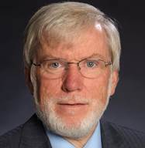
Christoph Stückelberger is founder and Executive Director of the global network on ethics Globethics.net, based in Geneva/Switzerland. He is part-time Professor of Ethics at the Theological Faculty of the University of Basel. He got his PhD with a doctoral thesis on peace ethics and his post-doctoral research on environmental ethics. His main fields of research are economic ethics, political ethics and development ethics. He has published many books and articles, among others on responsible leadership, global trade ethics, peace ethics, consumer ethics and work ethics.
He was president of ECLOF International, an organisation for micro-credit working in 30 developing countries, 1999-2007. Until January 2008, he was Director of the Institute for Theology and Ethics of the Federation of Swiss Protestant Churches in Berne. He was founder and president of Transparency International Switzerland, the Swiss chapter of the coalition against corruption. He was member of the Commission for International Cooperation of the Swiss Government and was president of its sub-commission on the WTO. He was member of the Swiss Ethics Committee on Non-human Biotechnology of the Swiss Government. He was director of the Development Organisation Bread for all.

Jason G Tower, Representative for Northeast Asia, American Friends Service Committee
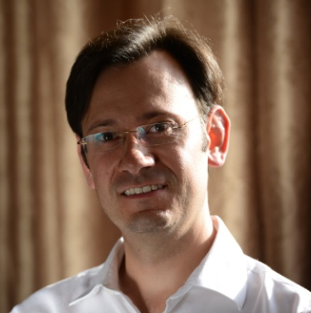
Jason G Tower is the Quaker International Affairs Representative for East Asia for the American Friends Service Committee, and a licensed mediator.
Jason is a specialist in Asian studies and has expertise in conflict resolution and sustainable development issues. He has lived and worked in Asia since 1999. Before coming to AFSC, he worked as a political scientist researching and writing on issues related to community governance and participation in China, and ethnic conflict in Southeast Asia. Jason has been a visiting fellow at Peking University, a U.S. Fulbright Research Fellow, and a Harvard Yenching Fellow. He has published articles on US-China relations, and regional politics in Asia, and held numerous consultancies for international organizations, law firms and NGOs on issues related to China and Southeast Asia. Jason’s current work with AFSC focuses on research and engagement with development stakeholders in Asia on conflict sensitivity. He has worked especially in Laos, Cambodia and Myanmar to build stakeholder dialogue and formulate approaches to conflict prevention between companies, NGOs and communities. Jason has also conducted extensive research on sustainable development and conflict in mainland Southeast Asia, looking especially at the impacts of foreign financed infrastructure projects on local communities, environments and armed conflicts. He recently received certification as an advanced company - community mediator in complex environments from the Graduate School of Business of Capetown University, South Africa, where he completed a course on this topic in 2015.

Radu Mares, Senior Researcher at Raoul Wallenberg Institute of Human Rights and Humanitarian Law, Associate Professor at the Law Faculty in Lund, Sweden
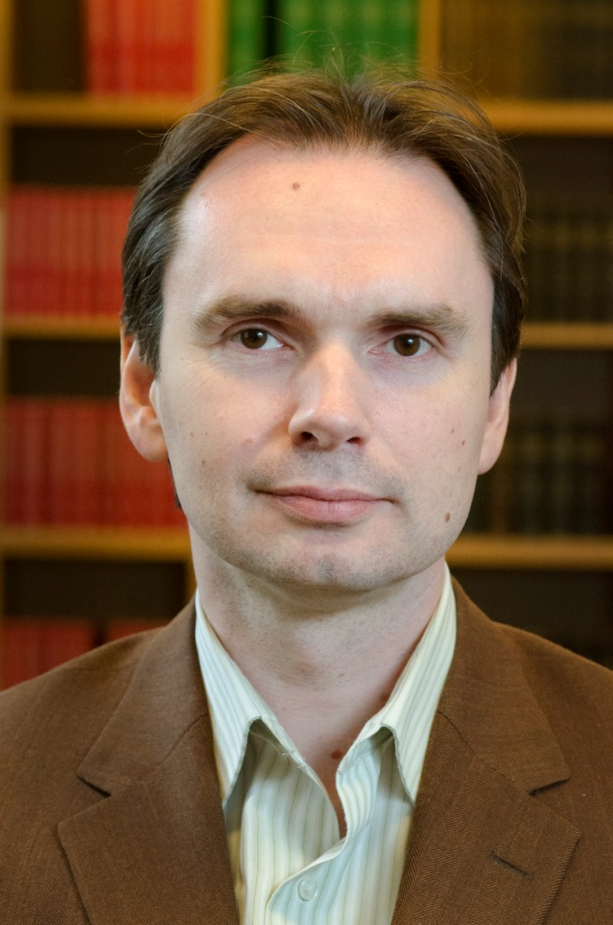
Radu Mares is senior researcher at Raoul Wallenberg Institute of Human Rights and Humanitarian Law, and Associate Professor at the Law Faculty in Lund, Sweden. He has Docent (2012), LLD (2006) and MIL (1998) law degrees from Lund University. Mares has specialised in the area of business and human rights. His work focuses on ways to strengthen the protection of human rights and good governance in the Global South. His preferred approach is socio-legal in order to study the interaction between law and corporate voluntarism, and to obtain effective regulatory and governance frameworks. Mares has written extensively about the UN Guiding Principles on Business and Human Rights, the transnational corporations’ responsibility to respect human rights, on the relation between law and self-regulation, on CSR in the mining industry and supply chain contexts.
Mares edited the book The UN Guiding Principles on Business and Human Rights – Foundations and Implementation, MartinusNijhoff Publishers (Leiden, Boston 2012), and authored The Dynamics of Corporate Social Responsibilities (MartinusNijhoff Publishers/ Kluwer Law International, 2008). The latest articles Mares published were ‘Corporate and State Responsibilities in Conflict Areas’, Nordic Journal of International law, Volume 83, Number 3 (2014) and ‘“Respect” human rights: Concept and convergence’ in Law, Business and Human Rights - Bridging the Gap, Bird, Cahoy, Prenkert (eds.), Edward Elgar, 2014. Currently he undertakes research in the project Due Diligence in international law and corporate social responsibility (CSR) (2014-2016), funded by Swedish Research Council (Vetenskapsrådet).
Robert Koepp, Director, Beijing Corporate Network, Economist Group
Robert Koepp is the Beijing Director of The Economist Corporate Network. An experienced trilingual (English, Chinese, Japanese) commentator, author, analyst, and manager, he has long worked with a wide variety organizations to gain a holistic yet practical appreciation of opportunities and challenges in China and other key Asian markets.

Zhuang Rui, Deputy Dean, Institute of International Economy, UIBE
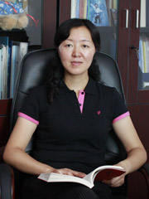
Professor Zhuang Rui is a full-time member of the academic staff at UIBE. She graduated from RenMin University of China and got the Doctoral Degree of Economics in 2004. Professor Zhuang was appointed as deputy dean of IIE (Institute of International Economy of UIBE) commencing 2009. She published more than 30 papers in renowned academic journals and 9 books，one of which won the second prize of “the 9th Beijing Philosophy and Social Science Research Excellence Award”.
Research fields: International economic integration, International economic relationship, Chinese trade and economy.
Liu Baocheng, Director, Center for International Business Ethics (CIBE), UIBE.
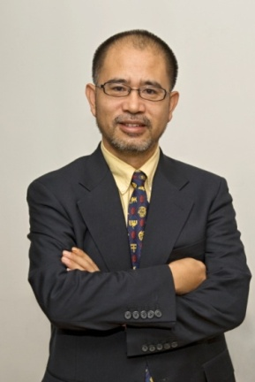
Dr. Liu earned his MBA and MSc from Seton Hall University, bachelor degree and PhD from UIBE. He was the founder and dean to Sino-US and Sino-French Schools of International Management, executive dean for the International School of Excellence at UIBE.
Dr. Liu is the founder and Director of CIBE and Center for Green Entrepreneurship UIBE. He is on the council of World Economic Forum, advisory board to the Department of European Affairs under MOFCOM, China Social and Economic Council, China Business Ethics Society.
His area of research and teaching covers marketing, business ethics, cross-cultural communication and business law. He is the winner of National Teaching Excellence Award. His hands-on business experience covers international trade, joint venture management, marketing research and legal service.
As current affairs commentator, he regularly voices his opinions on CCTV, RTTV, BBC and CRI.

Li Li, Associate Professor of Institute of International Economy, UIBE
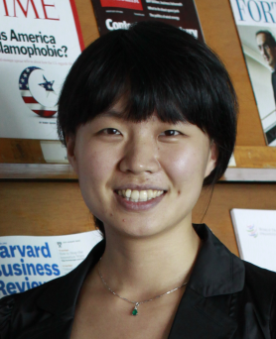
Dr. Li Li is Associate Professor of Institute of International Economy, UIBE and Director of China Research Center for Technical Barriers to Trade (CCTBT), UIBE.
Her main research fields are Technical Measures to Trade, Social Responsibility and Sustainable Development, Trade and Environment. She is registered expert of ISO Social Responsibility Working Group for ISO26000, and expert of China’s special working group on ISO social responsibility issues. She has participated the drafting of ISO260000 and the translation of ISO26000 into Chinese, also participated the drafting of several CSR related standard or guideline in China.

Li Dongning, CCTV-News Anchor
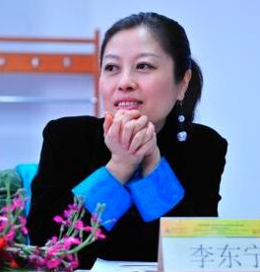
Li Dongning: MA on Journalism Studies, Cardiff University. She has been working for CCTV News since 1995, first as a presenter and reporter of features programmes including the first English science programme “Nature and Science”. Then she became a news anchor starting from 2005, hosting a variety of news programmes including CCTV News (the current News Desk), News Hour, China 24, and Asia Today

