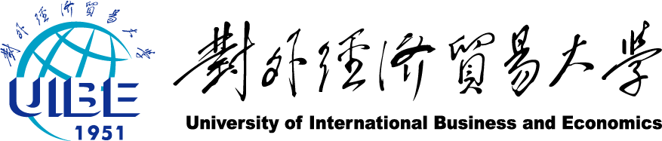

**From Customer Value to Social Well-being**

**Analysis on Huawei CSR Strategies**

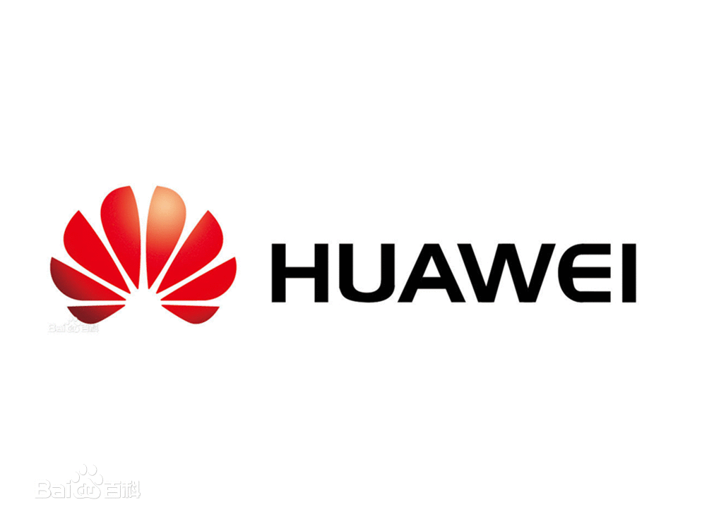

**By Yi Jiaxin**

Contents

**Why does a firm exist? 3**

**1. Building up Customers’ Perceived Value 3**

**1.1 Environmental Protection 4**

**1.2 Charity 7**

**2. Creating Stakeholders’ Common Value 8**

**2.1 Supplier 8**

**2.2 Community 10**

**2.3 Employee 11**

**2.4 Customer 13**

**Research Process 15**

**1. Literature Study 15**

**2. Empirical Study: In-depth Interview 15**

**3. Quantitative Analysis 15**

**Proposal 16**

**1. CSR Combined with Core Products and Services 16**

**2. From Sensitive Fields to Civil Areas 17**

**3. Increasing Publicity through Media 18**

**4. Emphasizing Stakeholders’ Participation 20**

**5. Assuming Responsibility for National Communication Security 21**

**6. Stimulating the Development of National Brand Image 22**

**Final Conclusion 27**

According to statistics, the average age of Chinese companies is 6.09 years, and no more than 50% of companies make it over 5 years, not to mention over 10 years. [1]Huawei has transformed from an unknown private company into one that ranks the 285th of the Fortune 500 in 27 years since 1987. It makes us wonder how Huawei survived the fierce market competition and turned into a remarkable company.

In order to get the answer, it is necessary to ponder upon the following question while analyzing the CSR of Huawei.

**Why does a firm exist?**

Why does a firm exist? Simply put, a corporation exists to create value, while Huawei puts it more expressly—to create lifelong value for customers. To that end, Huawei develops two strategies: one is to build up customers’ perceived value, and the other is to create stakeholders’ common value. The essence of these two strategies is to shoulder corporate social responsibilities, serving to increase the happiness of social subjects.

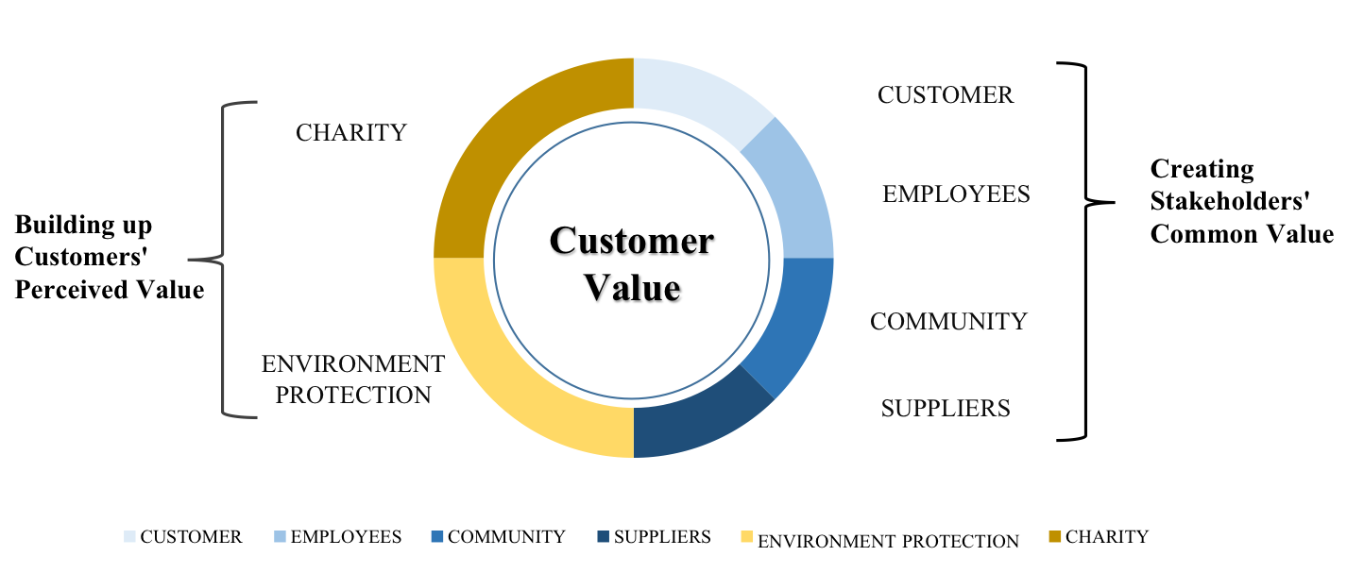

Figure 1

Note: On the left is how Huawei builds up customers’ perceived value, which is divided into environment protection and charity; on the right is how Huawei creates stakeholders’ common value.

[2]

We are going to take a close look at these two strategies and make proposals to Huawei on the basis of them.

1. **Building up Customers’ Perceived Value**

The key to becoming a great corporation is to win customers’ approval and respect, accumulating abundant brand equity and fostering convincing brand charisma. Huawei has built up a reliable and responsible corporate image among customers by significant and strenuous efforts in both environmental protections and charity donations.

* 1. **Environmental Protection**
* Green Products and Services
* Circular Economy

1. **Green Products and Services**

Huawei has implemented the environmental protection strategy of “Green Pipe, Green Operations, Green Partner, and Green World”. In addition to providing green ICT solutions to lower carbon emissions, Huawei is actively increasing its own energy efficiency while reducing carbon footprint and energy consumption.



Figure 1.2

Figure 1.3

1. **Circular Economy**

A circular economy business model has gradually become a strategic direction for stakeholders.

[3]

Figure 1.6

1. Huawei’s Reverse Logistics Management

[4]

Figure 1.7

1. Materials Recycling

Huawei has jointly established global scrap disposal platforms with waste service providers, providing one-stop services to dismantle and recycle telecom equipment that cannot be reused. This enables electronic waste to be handed in and environmentally friendly manner with resources recycle and reused, thus minimizing the landfill rate.

* 1. **Charity**
* Social Contribution
* Disaster Relief
  + 1. **Social Contribution**

Huawei contributes to society by supporting charity, education, environmental protection and health.

1. India: Supported students enrolled in Chinese universities through the Huawei Maitree Scholarship Program.
2. South Africa: Supported the Khulisani Foundation to promote ICT education.
   * 1. **Disaster Relief**
3. China: Guaranteed to stabilize communication in Ya’an after the 2013 earthquake and donated 3,000 handsets to the quake-stricken area.
4. Philippines: Implemented the Instant Network with Vodafone Foundation in disaster-stricken areas following Typhoon Haiyan.

 [5]

Figure 1.9

Figure 1.8

1. **Creating Stakeholders’ Common Value**

As is shown in Figure 1, in order to create constant values for customers and thus improve their sense of happiness, not only does Huawei continuously raise its own brand value, but also it collaborates with stakeholders in pursuit of better customer services.

* 1. **Supplier**
* Efficiency Management
* Business Innovation
  + 1. **Efficiency Management**

Huawei has gone beyond compliance and customer requirements, analyzed root causes of suppliers’ sustainability issues, explored high- value opportunities, enhanced the capabilities of suppliers, improved procurement efficiency, optimized business processes to reduce waste and business costs and strengthen competitiveness.[6]

1. Supplier Performance Management
2. Supplier Capability Development

Figure 2.2



Figure 2.3

* + 1. **Business Innovation**

Huawei always tries to incorporate forward thinking while cooperating closely with partners.

1. Supplier Environmental Performance
2. Huawei Green Partner Certification
   1. **Community**

* Voice Communications and Broadband Services for All
* Application of ICT Technologies and Nurturing ICT Talent
  + 1. **Voice Communications for All**

Huawei is committed to providing easy voice communications for people across different geographies. So far, their products and solutions have been deployed in over 170 countries and regions, serving nearly 3 billion people around the world. Among the areas they serve, many are underdeveloped and remote with harsh geographic environments. In addition, they are dedicated to providing instant communications services under certain emergencies, enabling ubiquitous voice communications services for everyone.

* + 1. **Application of ICT Technologies and Nurturing ICT Talents**

As an ICT solutions provider, Huawei is dedicated to providing customized ICT solutions that help enterprises in different regions improve their economic performance, productivity, and competitiveness. In this way, we help these enterprises gradually become the facilitators of the sustainable development of industries and the incubation of new business models. Huawei’s products have been widely applied in a variety of sectors including consumers, governments, public utilities, transportation, and energy.

* 1. **Employee**
* Benefits and Treatment
* Health and Safety
  + 1. **Benefits and Treatment**

1. Benefits: At Huawei, employees’ bonuses are closely linked to the business performance of the company, the business performance of their department, and individual performance.
2. Respect for Employees: In compliance with relevant laws and [7]regulations, Huawei prohibits forced labor and child labor, and has established non-discrimination policies.



Figure 2.6

* + 1. **Health and Safety**

Huawei prioritizes employee health and safety. For example, to meet customer requirements and comply with applicable laws and regulations, Huawei has set up specialized departments for EHS management of subcontractors and engineering delivery activities.[8]



Figure 2.7

* 1. **Customer—Improving Customer Satisfaction**[9]

Huawei strives to provide high-quality, secure, and affordable products and services to their customers and consumers. They work towards integrating product and service sustainability into every routine task across the company, thereby protecting consumer rights and improving customer satisfaction. For example, Huawei has set up regions and representative offices in major countries and continents around the world as they proactively seek to establish and maintain mutually beneficial relationships with customers. Huawei listens attentively to customers and better understand their needs by establishing multi-layer customer-facing organizations and communication channels through such activities as customer-facing strategic summits, user service conferences, receptions for customers who come to visit or audit Huawei, service hotlines, routine visits, open discussions, and third-party satisfaction surveys.

Figure 2.8

As we can see from above, in the course of lifelong customer value creation, Huawei has not only built up customer perceived value, accumulated its brand equity, but also protected local environments, raised the local economic and educational level, and increased the overall welfare of stakeholders. In a nutshell, Huawei has achieved great success in fulfilling corporate social responsibilities by assuming corporate social responsibilities actively and innovatively.

**Research Process**

**1. Literature Study**

I collected information and data by carefully reading and analyzing Huawei Sustainability Report and Annual Report. Meanwhile, I searched news reports concerning Huawei CSR both at home and abroad by virtue of Baidu search engine and *NewsBank*, a professional worldwide news database to see Huawei media exposure.

**2. Empirical Study: In-depth Interview**

To further collect information, prove results and acquire advice, I interviewed Mr. Willis Turner, the CEO of sales and marketing executives international, and Mr. Cai Yunpeng, one of Huawei’s clients and the Marketing and Sales Director of Taiji Co. Ltd.

1. **Quantitative Analysis**

Based on all information collected, I classified statistics, made graphs and conducted regression analysis with all relevant indexes to find out correlations between CSR and data, and finally drew conclusions by above quantification.

**Proposal**

As a socially responsible corporation, Huawei has put great efforts in to the performance of CSR. However, there still exists room for progress. Our proposal is divided into three levels: internal, external and national level.

* **On the Internal Level**

**1. CSR Combined with Core Products and Services**

The most efficient and effective way to enhance CSR is to combine it with the corporation’s core products and services. Huawei has done a good job in this respect.

For example, Huawei’s vision is to enrich life and improve efficiency through a better-connected world. To that end, Huawei has provided people living in developing countries with easy access to voice communication services as well as broadband installation.

While Huawei attaches great importance to underdevelopment and poverty in the third world countries, it should also disperse its products and services into ghettos and barrios in metropolis and remote areas in developed countries, which are often neglected.

**2. From Sensitive Fields to Civil Areas**

**2.1 Current Dilemma**

With its business expanding around the world, Huawei has long been entangled in the accusation of cyber security. In October 2011, Huawei became Iran's leading provider of telecommunication equipment, which included monitoring devices that could be used for surveillance. In October 2012, Huawei was tagged as “National Security Threat”, according to the US Congress report. In 2013, faced with this disadvantage, Huawei showed its attitude that it tended to slow down and withdraw some business in several regions, especially in the USA.

**2.2 Transformation to Civil Areas**

To convey that it is a company responsible for customers, community and the whole society, Huawei should shoulder more social responsibilities less related to the sensitive fields such as governments or military. This will be an effective way to reshape public opinion.

In the initial stage, Huawei could help funding some non-profit organizations such as hospitals where network security and protection of patients’ data are usually neglected and poorly funded. Huawei could help them to improve their medical devices and the network system to avoid malfunction and hacking. By ensuring civil entities such as hospitals running properly, Huawei would get more positive reviews and would be shaped as a cyber-defender in the medical field, which is way less sensitive than its old clientele.

* **On the External Level**

**3. Increasing Publicity through Media**

**3.1 Huawei CSR Public Exposure Relatively Low**

By virtue of Baidu search engine, I searched Huawei news reports by inputting key words “Huawei CSR”. The results show that there are only up to 20 positive reports covering different events from 2008 to 2014, regardless of those with same topic but from different sources, and these reports mainly focus on year 2014. In addition, there are fewer reports regarding Huawei leadership who has always been low-profile, and Huawei’s CEO Ren Zhengfei has just received domestic media interview since June 16, 2014.

Further, I searched all news reports from 2003 to 2014 related to Huawei CSR in NewsBank, a professional news database. The total number of reports seems to be small and areas where Huawei extensively conducted CSR activities are not well reported. The results are detailed in the following two graphs.

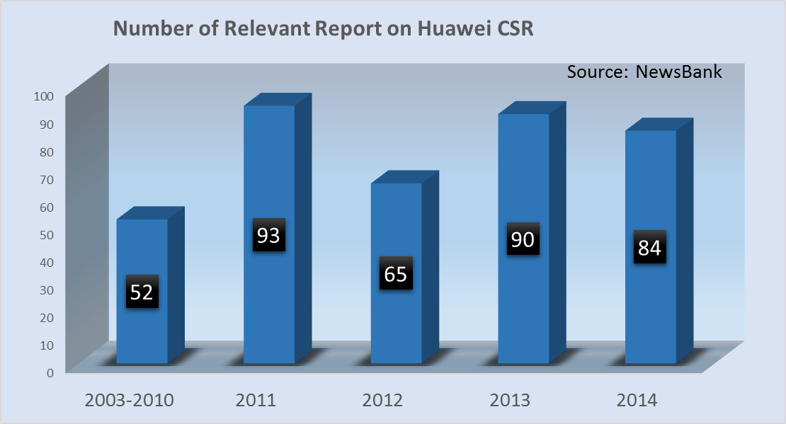

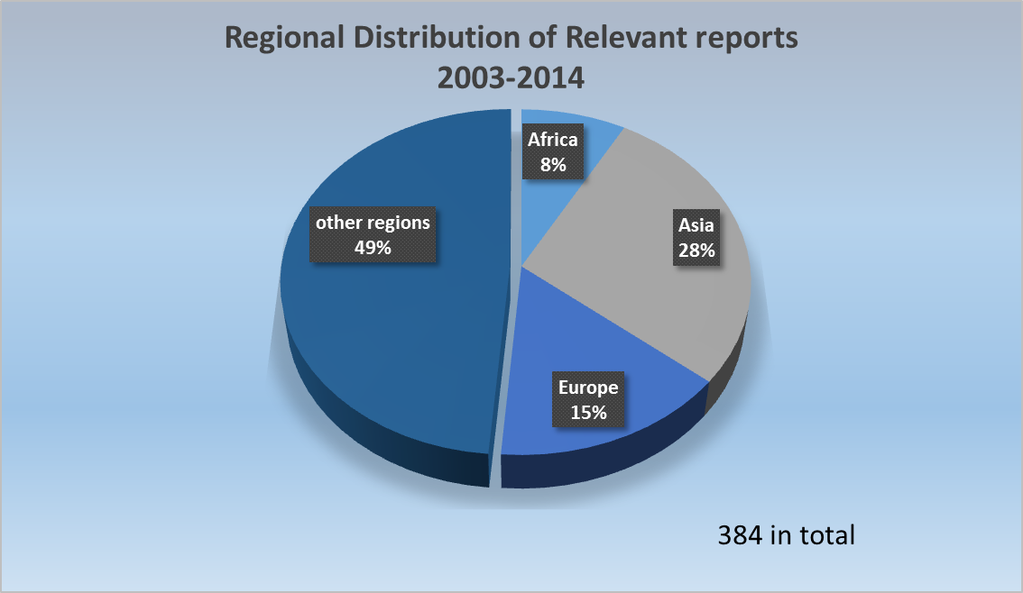

In conclusion, although Huawei has made efforts to increase its public exposure through media these years, compared with other well-known multinationals, there is still a lot of untapped potential.

**3.2 Empirical Study: In-depth Interview**

On this issue, I interviewed Willis Turner, the CEO of sales and marketing executives international, who specializes in company's strategy. Mr. Turner points out that exposing the company’s activities on CSR through media is significant, if the company is looking CSR as a way to raise the public attention to the issue. He added that if the issue is environmentalism for protection of environment, then the public should be interested as well, so by getting attention from the media, the company could actually help engage the whole community’s efforts.

**3.3 Enhance Media Exposure**

Therefore, my proposal is that Huawei should continue to increase its public exposure through media, cooperating with main stream media both at home and abroad and making full use of them to post its latest advancements and improvements to audiences, shape the image of positive CSR performer as well as industry leader in accordance with what it has done and set examples for other companies to join in through media. Meanwhile, in news reports, not only simply what it has done but also detailed introduction about Huawei, especially its unique ideal and attitude in CSR shall be embedded.

1. **Emphasizing Stakeholders’ Participation**

A great company should not only perform CSR itself, but also engage more stakeholders in the army of responsible corporations. In terms of the stakeholders’ participation, the foreign expert Willis Turner emphasized that not only those global companies should realized the importance of CSR, but those domestic companies, most of which are small companies, should also be socially responsible. According to 2013 Sustainability Report by Huawei, the company sets qualification and signs Sustainability Agreement with its suppliers, requiring them to pass the sustainability qualification to ensure that their system management and control capabilities meet Huawei’s requirements.

Meanwhile, each year Huawei organizes its employees to join in green activities and the scale is becoming much larger. Through encouraging stakeholders to participate in, Huawei has done good job in fulfilling social responsibility, which is worthy to be learnt from for other Chinese companies.

* **On the National Level**

1. **Assuming Responsibility for National Communication Security**

Based on its current achievements, Huawei has assumed the responsibility on the level of national communication security by providing mobile phone base stations, secrecy telephones, and other Information and Communication Technology solutions for China.

Huawei’s user, Mr. Cai Yunpeng, the Marketing and Sales Director of Taiji Co. Ltd., indicates that by this means Huawei protects China from leakage of confidential data and cyber security problems. Otherwise, China will be in the danger of information intrusion of other powerful western countries, such as the US. Their products of Apple Inc. have almost swept across the world and taken control of plenty of personal and national confidential information.

Therefore, Huawei’s contribution to this respect is of utmost importance and it should try to further expand its share in the Chinese market.

1. **Stimulating the Development of National Brand Image**
   1. **Huawei’s Contribution to National Brand Image**

Huawei has stimulated the development of national brand image by providing high-quality low-price smart phones. According to Mr. Cai, one of Huawei’s clients and the Marketing and Sales Director of Taiji Co. Ltd., Huawei has no need to produce mobile phones, because its expertise in the ICT field can make sufficient profit. But Huawei does not only offer Chinese consumers mobile phones with high value for money but also pushes other competitors like Samsung to undercut their prices. In this way, Huawei could successfully perform CSR for it promotes the development of national brand image.

* 1. **Current Performance of CSR by Chinese Companies**

According to Willis Turner, the CEO of sales and marketing executives international，it is shown by research that Chinese companies that engage in CSR are more likely to be companies that are taking a part in global marketing activities, which means that not so many Chinese medium-sized and small enterprises recognize CSR and are willing to take action. One of the biggest hurdles is their perception that performance of CSR does no good to their economic profits.

* 1. **CSR and Economic Profit**

However, my analysis of the following data shows contrary results.

|  |  |  |  |  |
| --- | --- | --- | --- | --- |
| Dependent  Variable  Independent  Variable | | F.roi  (Return on Investment) | F.roi  (Return on Investment) | F.roi  (Return on Investment) |
| Tree Saving | 0.0000159*** | |  |  |
| (93.81) | |  |  |
| Risk Support |  | | 0.00854** |  |
|  | | (19.33) |  |
| Employee Protection |  | |  | 0.0187* |
|  | |  | (6.85) |
| Asset | -0.00000807*** | | -0.00000818** | -0.0000155* |
| (-221.83) | | (-45.22) | (-7.26) |
| Profit | -0.00000761*** | | -0.00000460* | 0.0000168 |
| (-63.80) | | (-7.38) | (2.86) |
| Constant Term | 1.854*** | | 1.760*** | 2.266** |
| (368.16) | | (82.16) | (13.60) |
| Number of Samples | 5 | | 5 | 5 |
| R2 | 0.875 | | 0.930 | 0.996 |
| F | 1747.3 | | 1351.3 | 88.09 |

Significance Level * *p* < 0.1, ** *p* < 0.05, *** *p* < 0.01

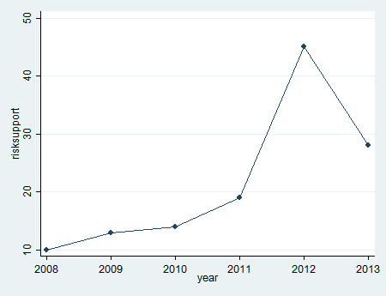According to the regression analysis graphs（Figure 3.1, Figure 3.2 and Figure 3.3），the three indexes（respectively the Percentage of Local Hires，the Investment in Global Employee Benefits，and the Number of High Potential Risk Suppliers）are positively correlated with Huawei’s Return on Investment（ROI）.

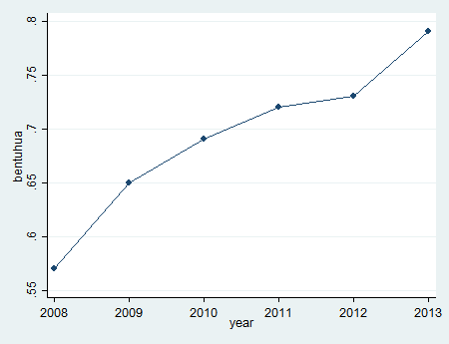 Figure 3.1

Figure 3.2

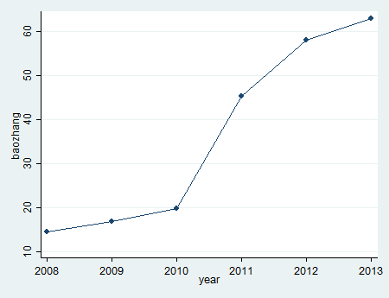 Figure 3.3

A corporation that puts greater efforts into CSR will gain a better social reputation and thus attract more consumers’ attention. Huawei is the most persuasive example to encourage more Chinese companies to join the army of CSR and consequently stimulate the development of national brand image.

**Final Conclusion**

As a leading global ICT solutions provider, Huawei is dedicated to creating lifelong value for customers by means of building up customers’ perceived value and creating stakeholders’ common value. In addition, Huawei strives to make a significant contribution to social well-being.

Huawei has built up a responsible corporate image among customers by putting great efforts in environmental protections and charity donations. Apart from that, Huawei cooperates with stakeholders (suppliers, community, employees and customers) and takes the responsibility for their happiness so that they can effectively help to create lifelong value for customers hand in hand with Huawei.

However, there still exists room for improvements. Huawei could make progress at internal, external and national levels respectively. At the internal level, Huawei could combine its core products and services with corporate social responsibility and expand its business to civil areas. Moreover, at the external level, Huawei should continue to emphasize stakeholders’ participation and increase its public exposure through media so as to shape the image of a positive CSR performer as well as an industry leader among the public. Finally, at the national level, Huawei could shoulder more responsibility in national communication security and the development of national brand image.

In the future, Huawei should continue to focus on its strategic sustainability initiatives and make improvements in CSR so that it could comprehensively incorporated them into its business operations in order to ultimately create long-term value for customers and contribute to social well-being.

1. Domestic Enterprise Survival Analysis Report[R]. the State Administration of Industry and Commerce, 2013:6
2. 2013 Sustainability Report[R].Huawei Investment & Holding Co., Ltd, 2013
3. 2013 Sustainability Report[R].Huawei Investment & Holding Co., Ltd, 2013
4. 2013 Sustainability Report[R].Huawei Investment & Holding Co., Ltd, 2013
5. 2013 Sustainability Report[R].Huawei Investment & Holding Co., Ltd, 2013
6. 2013 Sustainability Report[R].Huawei Investment & Holding Co., Ltd, 2013
7. 2013 Sustainability Report[R].Huawei Investment & Holding Co., Ltd, 2013
8. 2013 Sustainability Report[R].Huawei Investment & Holding Co., Ltd, 2013
9. 2013 Sustainability Report[R].Huawei Investment & Holding Co., Ltd, 2013